

# **Table of Contents**

**Table of Contents** **1**

**Business Understanding** **2**

Business Objectives 2

Situation Assessment 2

Project Goals 3

**Data Understanding** **3**

Data Collection 4

Data Description 4

Data Exploration 5

Data Quality Verification 7

**Data Analysis** **8**

SMART Question 1 8

SMART Question 2 11

SMART Question 3 13

**Conclusion and Recommendations** **14**

SMART Question 1 14

SMART Question 2 15

SMART Question 3 16

**Reference** **18**

**Appendix** **19**

# **Business Understanding**

## **Business Objectives**

Our client San Francisco International Airport (SFO) has shared their business goal of improving the overall customer experience.This project exemplifies the current situation, approaches, and actions that the SFO should consider. SFO has been one of the top leaders in the U.S. airport operations and aviation services industry for years. In facing emerging competition and the challenge of increasing consumer satisfaction rates, SFO is subject to a variety of pressures. First of all, increasing demand continues to put pressure on airport infrastructure. There isn't enough supply for airlines since it is difficult to obtain the slot times.

In the meantime, an airport does not want to reject a revenue-generating airline.Thus, many airlines are responding to shortages in some areas by ramping up capacity. Furthermore, customers' growing needs also need to be met. The airport should contain different types of services for customers. What's more, competitors are also one of the pressures.In addition to San Francisco International Airport (SFO), Oakland International Airport (OAK) and Norman Y. Mineta San Jose International Airport (SJC) are also located in the San Francisco Bay Area. The significant potential growth in the industry will motivate SFO to explore a larger range of business possibilities. For example, tourism development will increase passenger demand and industry competition, which provide a huge opportunity to SFO for further expansion.

This report will be shared with SFO executives, the CMO, and the Airport Commission, who are interested in the project's outcomes. SFO is generally trying to achieve better customer satisfaction by improving the passenger experience in the coming five years. To achieve the goal, this project will support SFO in identifying new insights that can enhance and better satisfy consumers' needs in the near future. By following the CRISP_DM framework, we will be analyzing the datasets to see SFO’s potential problems in customers dissatisfaction and provide our recommendations to solve them.

## **Situation Assessment**

The key performance indicator (KPI) for the need of our project is the consumer satisfaction rate. The goal set by SFO on this KPI is to make the consumer satisfaction rate reach above 4.4, which will be measured by average of the sample population. Before achieving the goal, we should also acknowledge that there will be a performance gap. The gap for SFO is the difference between the current and expected consumer satisfaction rates. More specifically, if the current consumer satisfaction rate is 4.0, the KPI will drive SFO to reach 4.4, which is SFO’s business objective. In order to find out the reason behind the gap, we would divide our sample customers into smaller groups to see the common characteristics they share to rate a similar score for SFO. By doing this, we will learn more about why people are satisfied or dissatisfied and what SFO could do to make things better in the future.

Before we move on to the actual dataset, it is pretty important to figure out our challenges and the specific information that could fix the challenges. Several crucial and unfixed information needs could encourage SFO to achieve the higher goal of improving the overall customer satisfaction level.

One of the information needs would be the challenge of reducing the performance gap between SFO’s current average customer satisfaction rate and SFO’s KPI objective. The data from the survey can give us an idea of the current customer satisfaction ratings and the main reasons for the gap. Also, using and analyzing the data related to the actual ratings can help us understand customers’ current needs and preferences for airport service and perceive where SFO is not doing well. As a result, we will be able to assist SFO in focusing on those areas for improvement and delivering higher quality customer experiences in the future.

Another critical information need in this project would be how customers with different traveling objectives set their rating criteria for the airport experience. Dividing those customers with different requirements and rating criteria in our dataset could help us find their shared preferences for a wonderful airport experience. Also, looking for the relationship between customer traveling objectives and the reasons behind their rating decision would bring us more insights into how to improve the services for different types of customers in a targeted manner.

Understanding the trends in customer satisfaction and how things change from past to future are also crucial information need, which can guide us to know which aspects of the airport experiences passengers will now value more. Looking through the survey data from 2014 to 2018 can help us understand the changes in the customer’s attitudes and may bring insights into airport service industry trends. We can also compare the data from different years to look for the changes in the most influential factors of customer satisfaction rating from past to future. Therefore, we would be able to make some predictions of customers’ future preferences based on the evolution of interviewing results.

## **Project Goals**

Our analysis will be mainly covering the following three SMART questions:

1. **What will we need to do in order to improve the score over 4.4 in 1 year?**
2. **What will we need to do to make Terminal 1 the best terminal in SFO in 2 year?**
3. **What will we need to do to improve the safety and security of SFO in 1 year?**

The final success of SFO will achieve the goal of improving the customer satisfaction rate in the coming five years and solving problems successfully. It will also help SFO attract more customers and strengthen its position in the industry.

# **Data Understanding**

## **Data Collection**

All the customer survey datasets are acquired from the official website of SFO. We will use the data from 2014 to 2018 for the analysis, and the dataset from 2018 will be used as the most current data. All data from all years are based on the interviews with randomly selected customers in SFO’s terminals, boarding areas, or mail.

## **Data Description**

The passenger dataset each year covers customers’ demographic information and their satisfaction with Airport facilities, services, and initiatives. Table 1 describes the number of sample interviewers (records) and variables in each year’s survey data.

| Year | Records | Variables |
| --- | --- | --- |
| 2018 | 2809 | 100 |
| 2017 | 2831 | 97 |
| 2016 | 3088 | 97 |
| 2015 | 2958 | 87 |
| 2014 | 2818 | 93 |

*Table 1: Data Collecting*

Based on our preliminary observations, we realized that most of the variables in the datasets are ordinal and nominal data. Taking the data from 2018 as an instance, it only contains two continuous variables that could be used in meaningful calculations. The reason is most data is telling the rating levels, which may cause some troubles in doing the relationship analysis later. But notice that is making us more careful in choosing our modeling techniques. Furthermore, we found several variables containing a significant number of blank cells in datasets from 2014 to 2018 years, and most of them refer to very detailed reasons behind the interviewer's rating, which give us insights into the survey's design problem and customers' attitude towards these questions. These findings can help us clean the data and reveal some interesting clues.

The dataset is also a great guide for us to imagine the possible experience process of a common passenger, which might be:

Getting to the airport - Looking for the correct airline counter - Printing the ticket - Checking bags - Go through the security - Purchase in store or restaurant - Using lounge/restrooms/other facilities - Going to the gate - Waiting for boarding - Get on the plane - Departure

The possible experience process above may give us some insights in looking for potential correlation between variables and the recommendations when we perform the analysis. We notice that all the cases in the dataset are from a departure view, which means the result in the survey can only represent the attitude of passengers who are departing from SFO. SFO still needs to apply more specific surveys covering the arriving customers if they want to learn more comprehensive potential problems of the airport.

## **Data Exploration**

## 

*Figure 1 Correlation Matrix*

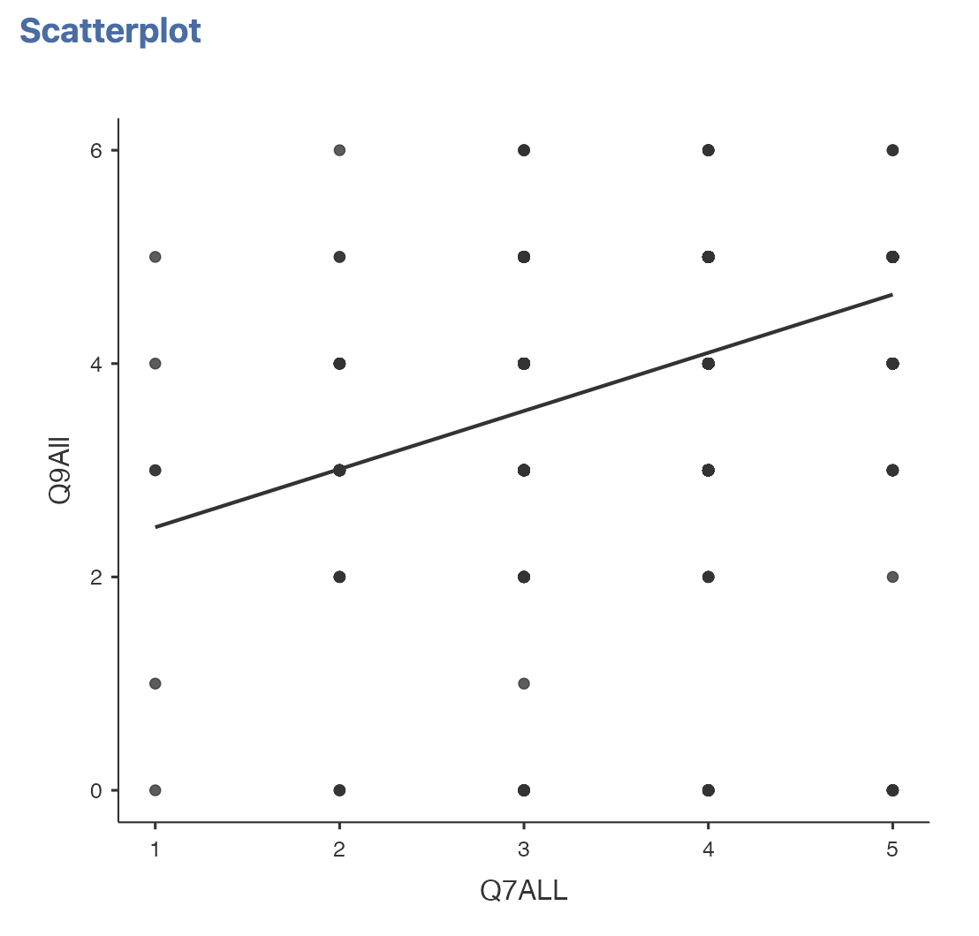

*Figure 1.1 Linear regression analysis*

After observing data in Jamovi, we found that the cleanliness of SFO overall is positively correlated with SFO airport as a whole, and the R value is more significant than other variables except NETPRO, which is the indicator of how possibly you would recommend SFO to your friends or family. We didn’t analyze the correlation between “Q7ALL” and “NETPRO” because it is obvious that if consumers are satisfied with SFO, they would naturally tend to recommend SFO to their friends or family. For the relationship between the cleanliness of SFO and SFO’s overall satisfaction, it can be interpreted that if the rating of cleanliness is higher, the rating of the entire SFO airport will tend to be higher. This correlation offers us the insight and direction for us to start improving consumer satisfaction rates by advancing the intensity of SFO’s cleanliness levels.

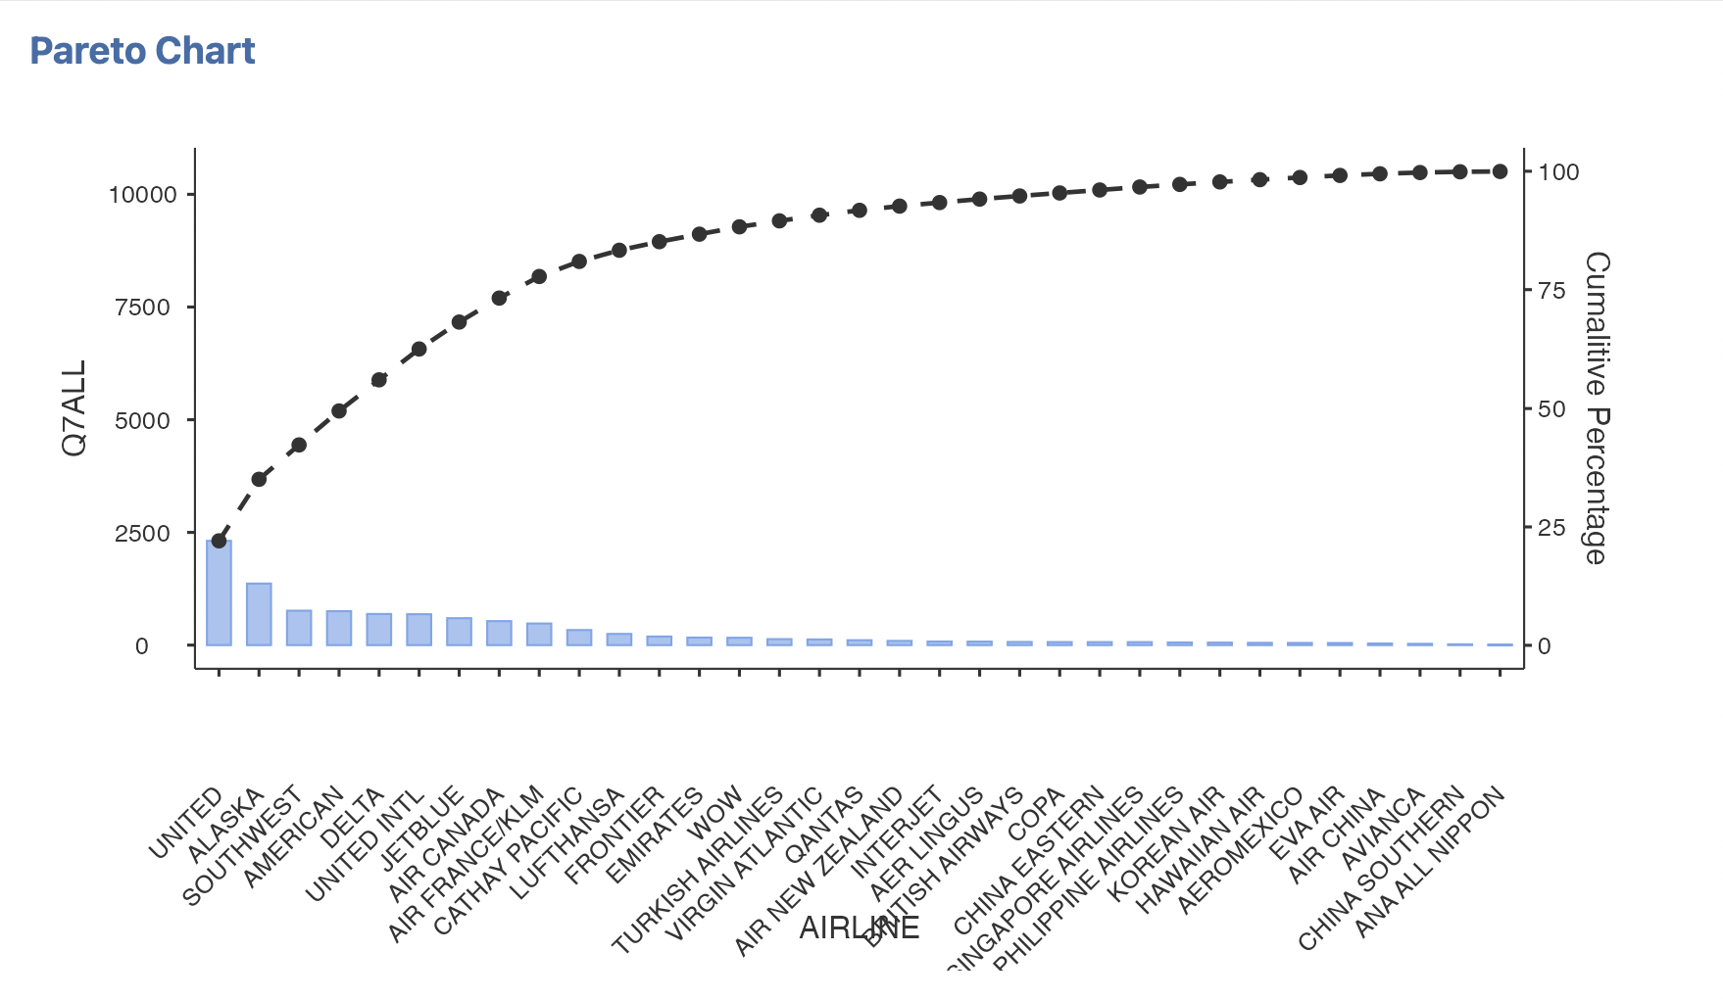

*Figure 1.2 Pareto Chart*

The Pareto chart above also gives us some insights before we start cleaning the data. As we can see, 80% of the airport's overall rating score came from the 20% of passengers in the whole sample who take United, Alaska, Southwest, American, Delta, United INTL, Jetblue, Air Canada, Air France, Cathay Pacific, Lufthansa, and Frontier Airlines. This may tell us the most popular airlines in SFO and which airlines serve SFO's primary customers. It is also interesting to see that SFO's primary customers are also customers of United Airlines, which may provide some hints on who SFO is and should be targeting. Also, this information could tell us which group of customers would influence the overall rating the most, probably will give us a direction to perform deeper analysis.

## **Data Quality Verification**

To better accomplish our project objective, we carefully reviewed historical data from 2014 to 2018 and decided to focus mainly on the data from 2018 as a foundation of the analysis. Using the latest and newest dataset would help us to understand the current situation of SFO. Also, because of the most significant number of variables that data from 2018 possesses, it grants us a broader scope of factors and more detailed information to consider in the analysis.

After performing some initial descriptive analysis (Table 2 and Table 3) using Jamovi, we notice that 18 out of 100 variables lack more than 95% data in the sample. This could be strong evidence that the dataset is very dirty, and those variables that lack too much data will probably be deleted as they can not represent a larger population. However, descriptive analysis cannot recognize missing data of non-numeric variables such as variables expressed in word form, especially when the dataset has several ways of showing missing data. For example, the missing data in variable “QALL” is described as “BLANK” instead of a blank cell, and the missing data are shown as “N” from column A to U. Therefore, we do need to perform further cleaning in the data preparation phase. Overall, the dataset contains a lot of dirty data and missing information. Due to the number of variables, we will only prepare and clean those variables that might be related to the specific framed question. Even if the data quality is not perfect, many complete and informative variables could still support our subsequent analysis.

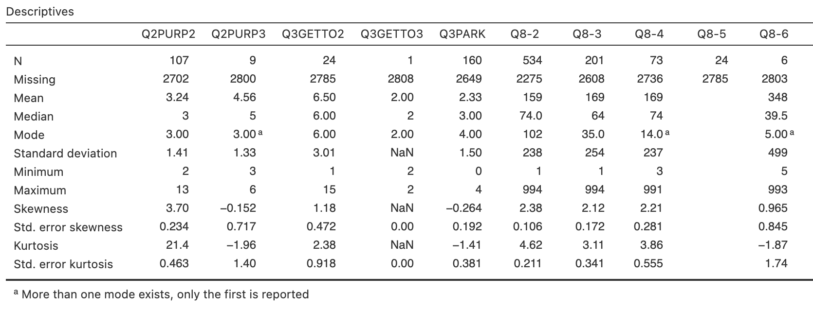

*Table 2: Descriptive Analysis I*

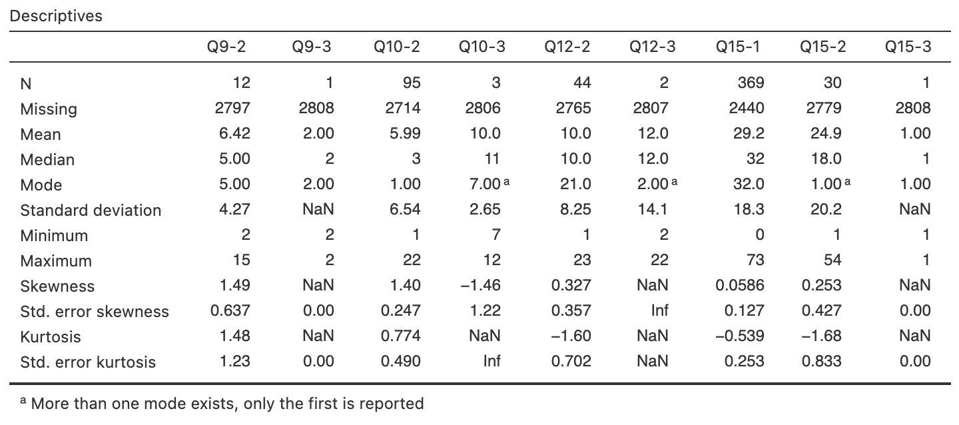

*Table 3: Descriptive Analysis II*

# **Data Analysis**

Due to the massive number of variables, we will select representative variables for specific framed questions instead of using all variables simultaneously.

## **SMART Question 1**

To improve the customer satisfaction rate and find out problems, we will focus on variables related to the general rating, including variables from Q7 and variables that may affect a passenger’s rating criteria, such as income, gender, and age. Since some variables display “Blank,” we decide to replace them with blank cells, resulting in 184 variables. It has no significant impact on the end result. We filter out the "0" and "6" variables when we build the model because these numbers will influence our final rate.

After cleaning the data, we analyze the data from the overall rate of SFO. According to the correlation matrix (Appendix 1), we find that all variables in Q7 are positively correlated to the overall rate. So, we filter the stronger positive correlation between those variables and find out which has the lowest mean from the descriptive statistics.

The average grade for each section exceeds 3.5, and the overall rate achieves 4, indicating that customers are satisfied with the general condition of the airport. However, our goal is to improve the rate over 4.4, so some problems are still affecting the overall performance. We notice that the “Store” has the lowest mean (3.55), and the majority of customers rate 3 for this question, which has the worst performance.

Since the store rate influences the overall grade of SFO, we use a linear regression model (Figure 2.1) to better clarify the relationship between the store and the overall grade for the SFO. According to the correlation matrix, these two variables have a positively correlated relationship of 0.562. It means that when customers are satisfied with the service in the store, the overall rate for SFO improves.

***Formula: Y = 0.457X + 2.369***

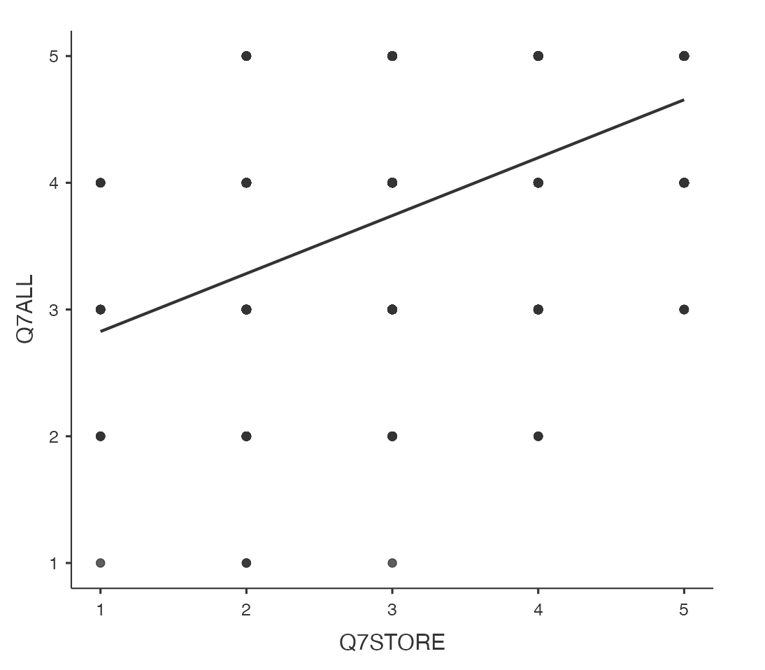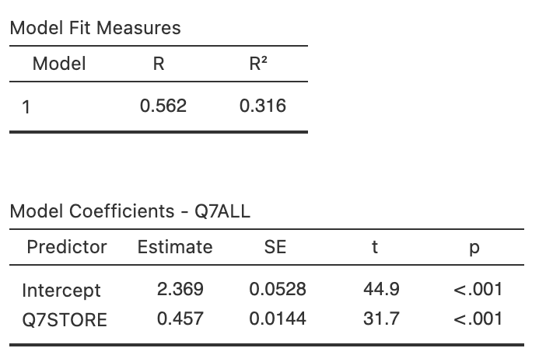

*Figure 2.1: Linear Regression Figure 2.2: Model Coefficients*

To determine which customer groups are dissatisfied with the SFO store, we employ the clustering model (Figure 2.3) to identify those customers. Cluster 4 has the lowest rate for Q7ALL in this graph. When we analyze cluster 4, we can observe some interesting things. Since there is a relationship between Q7ALL and Q7STORE, the lower rate of stores will cause a lower overall experience rate in SFO. We can imagine a female customer who is 35-44 years old with $100,001-$150,000 income and a carry-on bag staying for a long time in Terminal 3. After she wanders around for a while, she gets nothing from the store. Thus, she is dissatisfied with the stores at SFO. What’s more, since she doesn’t check her luggage, she will be inconvenienced while browsing the stores, negatively impacting her shopping experience. To determine the specific problem of the store, we look through the variable Q15PROBLEM in the database. Most customers complain that they cannot find the product they want in the store, and few customers consider store service is poor and prices are too high. Thus, they don’t want to shop in the store and give the lower rate for the Q7STORE variable. After we find those problems, we will provide recommendations for SFO to improve the store service.

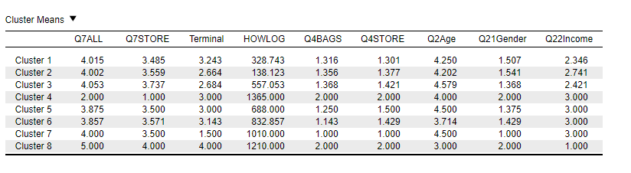

*Figure 2.3: Cluster Means I*

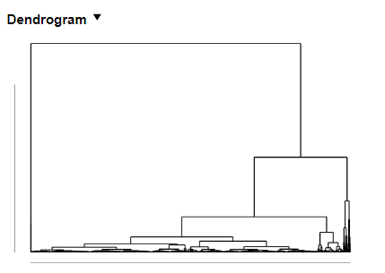

*Figure 2.4: Dendrogram I*

Using the clustering model (Figure 2.5) and building a dendrogram (Figure 2.6) in the JASP, we find the similarity of customers who give low grades for overall experience in the SFO. In cluster 8, the rate for customer satisfaction drops to 1. We can imagine a portrait from this diagram that females 65 years old and over and with over $150,000 income find the SFO's services unacceptable. We can assume that the high demands of the elderly at the airport may be because some amenities are not convenient enough. “According to the Administration on Aging, people who aged over 65 projects from 40 to 70 million, 13% to 19% of the population, through 2010-2030” (Ali, 2014). More and older adults start traveling after they retire. Thus, this problem needs to be solved, and SFO needs to maximize the needs of the elderly.

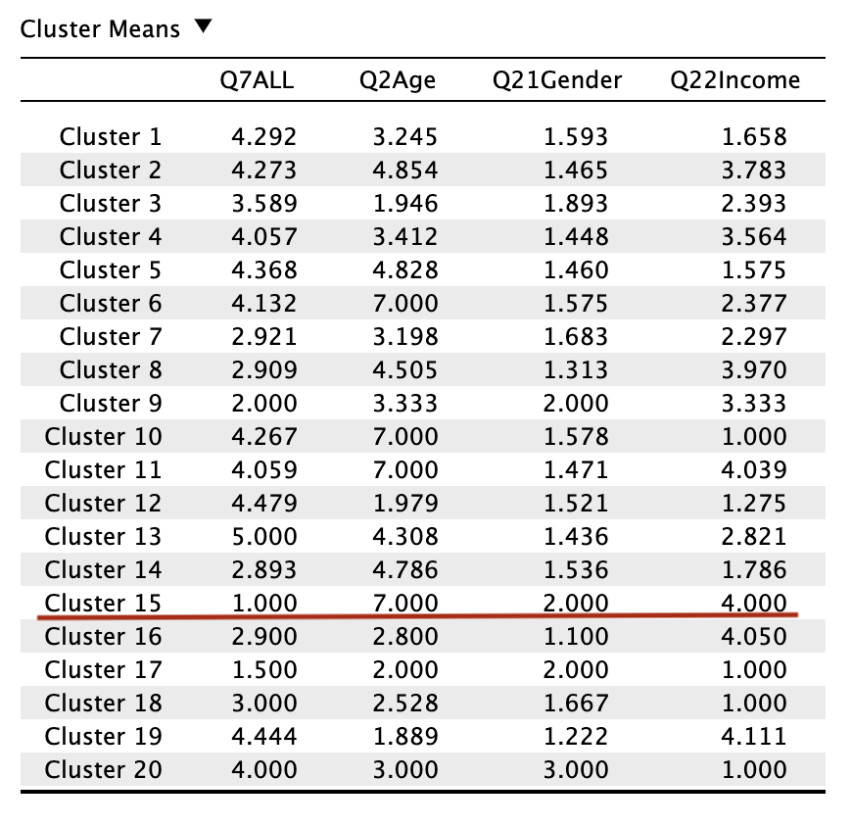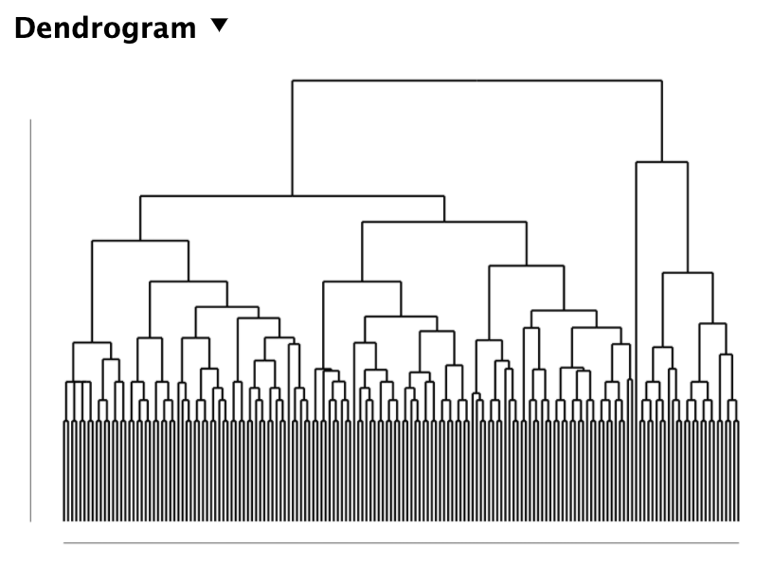

*Figure 2.5: Cluster Means II Figure 2.6: Dendrogram II*

## **SMART Question 2**

After reviewing the whole dataset, we decided to select rating and customer profile variables for further analysis. Since the original dataset does not have “Terminal,” we add a new variable, “Terminal,” based on the categorization of Airlines. Before data cleaning, we replace all cells of missing data from “0”, “6,” or “BLANK” with blank cells. Variables with more than 90% missing data are deleted from our datasets. To make the correlation matrix more convincing in the further modeling, rating variables with more than 50% missing data will not be used to reduce bias. Descriptive analysis conducted by Jamovi helps us filter out these variables very quickly. Therefore, variables like Q7PARK, Q7AIRTRAIN, Q7LTPARKING, Q7RENTAL, and Q12PRECHECK are deleted in this step.

To make Terminal 1 the best in SFO airport, we need to find out what contributes to the current overall rating of Terminal 1 and analyze the deeper reason behind it. After we cleaned and formatted all the data, the correlation matrix (Appendix 2) of all the rating variables for Terminal 1 implies that the rate of information booths in the departure area (Q7INFOUP) has the most significant correlation with the overall rating (Q7ALL). Therefore, we establish a linear regression model (Figure 3.1-3.2) to show the correlation between Terminal 1’s information booth rating at departure and its overall rating:

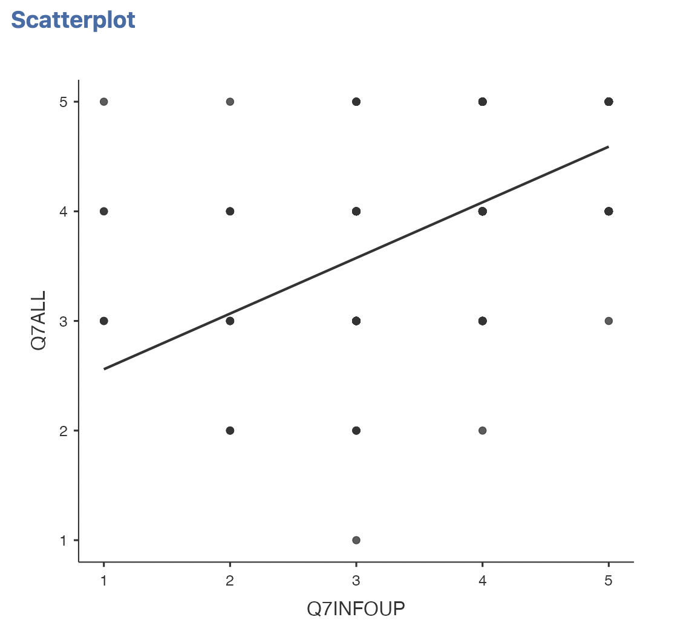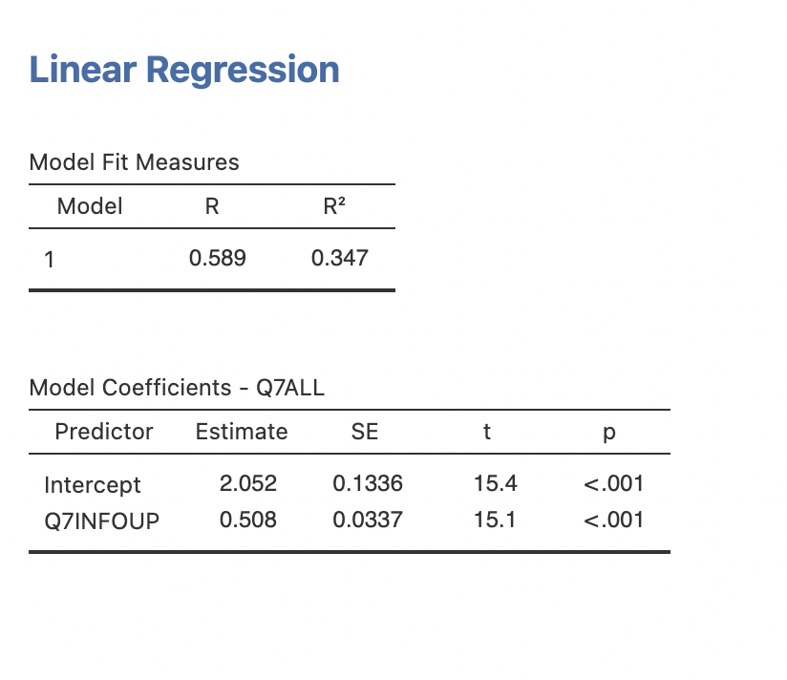

*Figure 3.1 Figure 3.2*

***Formula:******Y = 0.508X + 2.052***

This model shows a clear linear relationship between these two variables, which verifies that the higher people rate the information booths in departure, the higher the overall rating of Terminal 1 would be. It also shows that Q7INFOUP is the essential rating variable for Terminal 1 except the Q7ALL, which means that improving the information booth service in departure areas could be a great way to improve Terminal 1’s overall rating. For example, if SFO has a customer who rates the information booths at departure areas at a 5, we can use this regression model to predict that they are more likely to be satisfied with SFO’s overall performance.

With this correlation in mind, we build a clustering model (Figure 3.3-3.4) to find common characteristics of customers that use Terminal 1. We use all the variables related to a customer profile or characteristics in the clustering because we can’t assume the relations among variables. We use the Q7ALL and AQ7INFOUP as well because these two rating variables are the most crucial indicator of Terminal 1’s performance based on the correlation we found before.

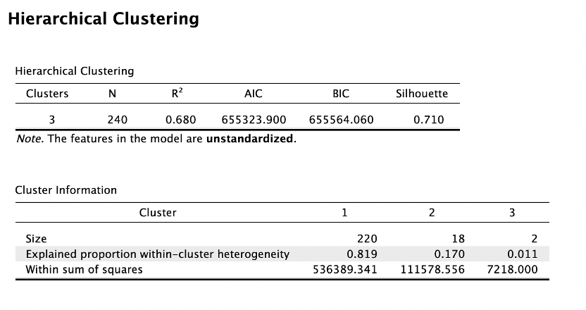

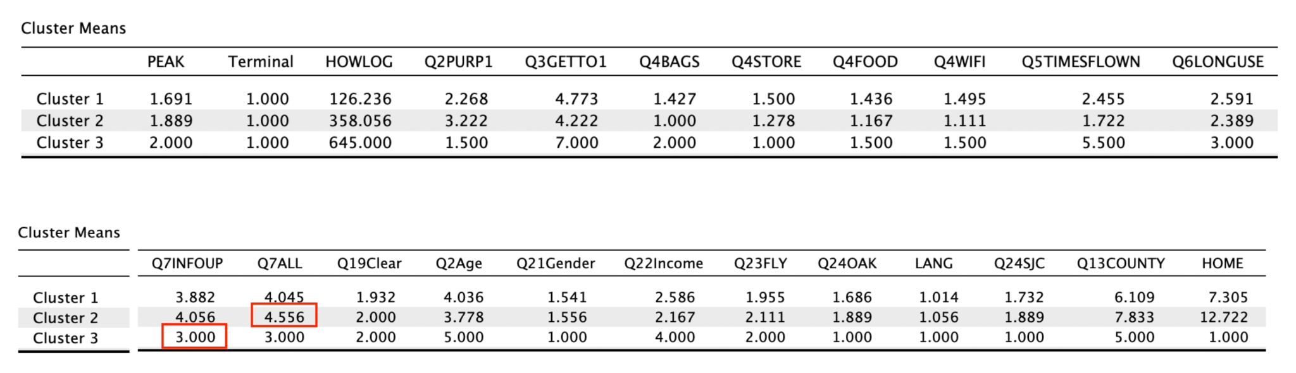

*Figure 3.3*

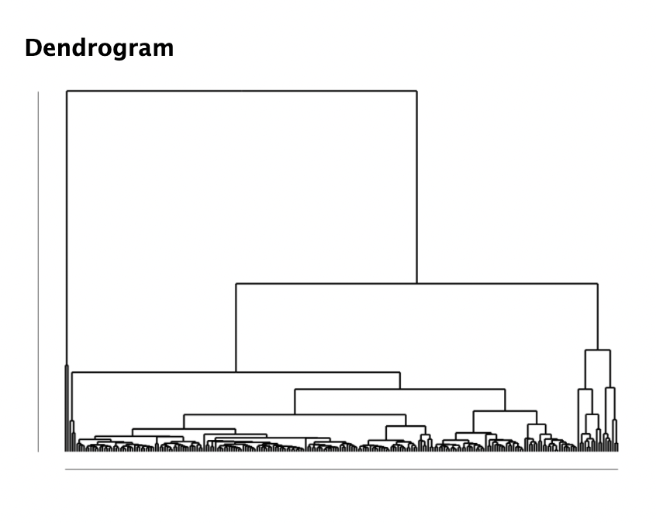

*Figure 3.4*

Looking at the Cluster Means table above (Figure 3.3), we can see that customers in Cluster 2 have particularly high customer satisfaction (both Q7INFOUP and Q7ALL) in Terminal 1. In contrast, Cluster 3 has a terrible rating in both Q7INFOUP and Q7ALL, which encourages us to look deeper into those variables to see what characteristics of customers make up these two clusters. The similar performance in Q7INFOUP and Q7ALL in the same cluster also verifies their high correlation between each other.

To assess the model, we can’t say it is a perfect model since Cluster 3 only clustered two sample cases, which may not be accurate to represent a large population. But it does successfully produce three meaningful clusters with a clear dendrogram (Figure 3.4).Although the cluster did not divide customers evenly in numbers, we still have some interesting findings in the result. Especially from Cluster 3, the two customers in that cluster share some very similar but distinctive characteristics, which is very different from the characteristics from other clusters even if they only have two people in the cluster. Therefore, the clustering result with particular high and low satisfaction rates would still be meaningful for our deeper findings.

By looking into and comparing Cluster 2’s variables cluster mean with other clusters, we can articulate that customers in this cluster share some common characteristics: they came more than 2 hours early before the departure time; all of them have only one checked bag; most of them buy stuff from store and restaurant; they are not old customers; they are young people; their income level is between $50000 and $100000; their home is not in California; most of them never use other airports around SFO. This profile information could be helpful for us to gain insights into what kind of customers are more likely to rate higher for Terminal 1, which could help us to define who would be SFO’s best client and whom SFO should target in the future.

To summarize the critical points in this profile, Cluster 2’s customers are middle-income young new customers who came at a reasonable time to the airport in advance and would like to spend money and time in stores and restaurants.

When we investigate the row of Cluster 3, we can also find some exciting features of customers in this cluster: they don't come to the airport at peak time; they reach a tremendously long time earlier before departing (more than 10 hours), which is impressive; they all use door to door van service; they didn't use store; they are returning customers; they feel bad about information booths; they are 45-54 years old; they are all male; they have very high-income level; California is their hometown; they have used other airports around SFO before.

To summarize the critical points in this profile, we realize that customers in cluster 3 are high-income level frequent customers who come exceptionally early at the airport and require excellent information guiding service.

## **SMART Question 3**

After observing the correlation matrix (*Appendix 4*), we know that the feeling of safety is positively correlated with the measure of cleanliness, and the cleanliness is positively correlated with the rate of the whole SFO airports. Thus, to improve SFO’s consumer satisfaction rate, we need to improve the safety and security of SFO within a year. In reality, the best practice to reduce the crime rate and make people feel safer is to increase the number of police presence and frequency of patrols. However, SFO is a vast airport that covers 21.07 square kilometers, and it is hard to guard every corner of it. Thus, wisely allocating the police force is crucial for ensuring the safety of SFO. To figure out which terminal should reinforce safety measures, we use clustering models and build a dendrogram as in figure 4.1 and figure 4.2. We use clustering models instead of others because they can help us find the characteristics of respondents within different levels of the cluster.

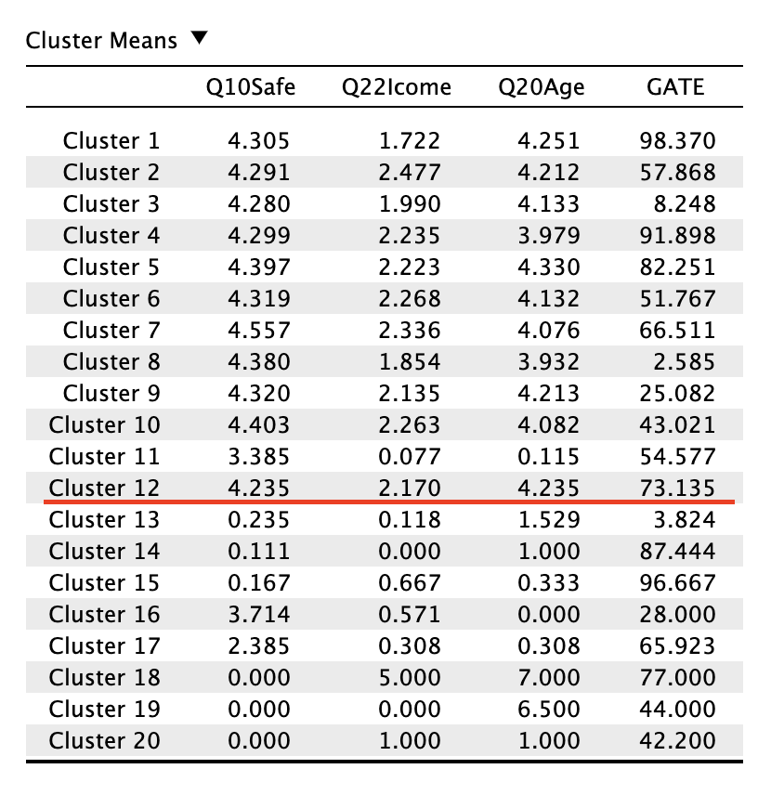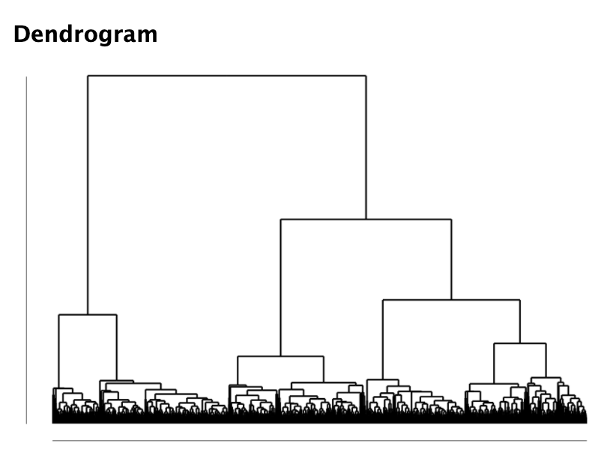

*Figure 4.1: Cluster Means Figure 4.2: Dendrogram*

The variables we choose to analyze are "Q22Income", "Q20Age", and "Gate." "Q22Income" represents the level of income of the average respondents. "Q20Age" is the age of respondents, and "Gate" is the gate that respondents get abroad. The meaning of this cluster model is to observe how people in the same income and age range have a sense of security when they are boarding at different gates of SFO airport.

The result is acceptable since it clearly shows that people within a certain age and income group will have certain feelings towards different terminals. It is not recommended to adjust the parameter because we have chosen the variables that most correlate with safety measures and give firm conclusions. However, it is with trying an alternative approach of using different methods if we have extra variables that describe SFO’s consumers more accurately.

# **Conclusion and Recommendations**

## **SMART Question 1**

Using the data from 2014-2018, determine whether the situation improves or worsens for Q7STORE and Q7ALL. Based on Figure 5.1 and 5.2, the trend is downward this year. Thus, it is even more critical that we address these issues quickly to improve SFO satisfaction in one year.

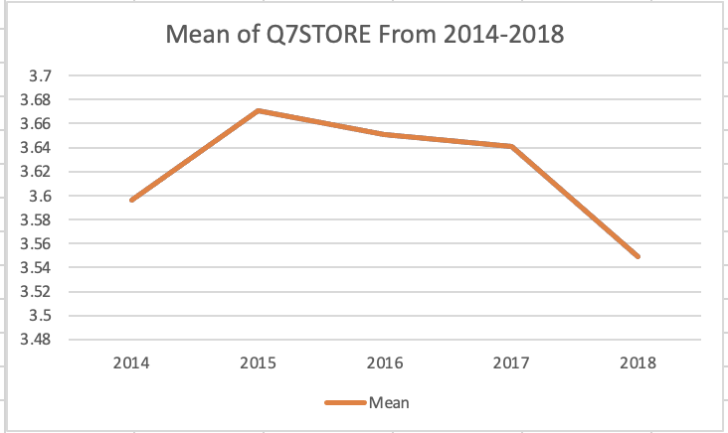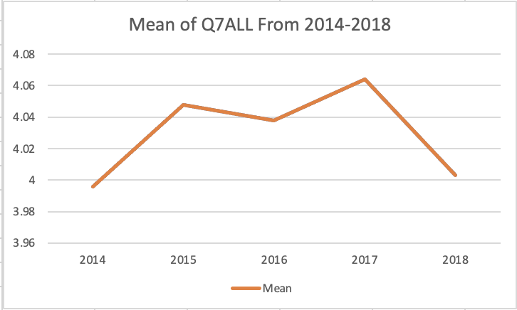

*Figure 5.1: Q7STORE Trend Figure 5.2: Q7ALL Trend*

Our recommendation is to increase the variety of products in the store and match the requirements of 35-44 years old women as much as possible; meanwhile, product prices should be lower than before. SFO can also use some marketing strategies such as discounts. Furthermore, SFO can construct storage for customers who have carry-on bags and need to stay in the airport for an extended period of time. Hanging out at the airport with carry-on bags can be inconvenient at times. So, having a locker could be beneficial to them.

Moreover, since older people tend to give SFO lower ratings, SFO needs some improvement about this issue. According to the database from 2018, some people complain about the sign/information boards providing confusing/incomplete information, and finding a gate or terminal may be challenging. Those are important for older people because they need the sign to know the direction. As a result, SFO should make the sign visible and remove redundant signage. SFO should also provide customers with complete information to use and read. Furthermore, providing some amenities for the elderly are necessary, such as designing some home toilets commonly used by the elderly, providing more wheelchairs, etc.

## **SMART Question 2**

|  | Income | Age | Frequent Flyer | Time before Departure | Shop at Store/Food | Information Booth Rating | Overall  Rating |
| --- | --- | --- | --- | --- | --- | --- | --- |
| Cluster 2 | Middle | Young | No | 6 hours | Yes | 4.056 | 4.556 |
| Cluster 3 | High | Middle | Yes | 11 hours | N/A | 3.000 | 3.000 |

*Table 4*

To make a clear comparison between Cluster 2 and Cluster 3 with opposite satisfaction rates, we produce the table (Table 4) above to see how opposite two clusters differ. By comparing the two clusters' characteristics, we can find that these two groups of passengers represent two different customer types in many aspects. The clustering helps us articulate that customers who are satisfied with Terminal 1 tend to be young people with middle income and are usually not frequent flyers. Based on this observation, we would recommend Terminal 1 to try to make young people as their frequent customers. Attracting more young people like them will help to improve Terminal 1’s overall rating since this group of people tends to be Terminal 1's target customers. To make them become returning customers, SFO could provide them with a phone App to help them easily find the facilities, stores, and restaurants in Terminal 1. Moreover, since they come early and are interested in shopping in stores and enjoying food in the airport, we recommend SFO to absorb more popular store brands and restaurants to join Terminal 1 next year to attract more young customers.

For customers similar to cluster 3, SFO needs to find a way to improve their satisfaction with the information booth rating. This cluster of customers is high-income customers with a high requirement for service quality. Therefore, we recommend SFO to add VIP information booths specially designed for those frequent flyers with high mileage at departure areas to provide them better services with fewer people lined up. In addition, since this group of customers is more likely to come exceptionally early to the airport, SFO could open a VIP lounge in Terminal 1 that requires additional charges for these high-income customers who would like to spend time in a more comfortable and quiet place with better services and complimentary snacks and drinks. With better services and a great place to spend their time, we believe customers similar to Cluster 3 would see them as Terminal 1's treasure customers and rate higher in the next year.

## **SMART Question 3**

With a picture of targeted consumers, the analysis answers the business question of which part of SFO has the lowest safety feeling. The conclusion is that people are concerned about their safety in terminal 3. We use clustering methods to categorize people who have similar characteristics and how safe they feel in different terminals. Looking at figure 4.1, we should first eliminate the cluster level with numbers less than one, as it represents the cluster with no or multiple responses. After comparing and eliminating the invalid cluster, we notice that at cluster 12, the safety measure drops to the lowest level, which is 4.235.

This gives us a picture of the population that people aged 35 to 44 with incomes ranging from $50,000 to $100,000 feel unsafe in gate 73 at SFO airport. We discovered, after tracing back to the data set, that United Airlines, located in terminal 3, owns the boarding areas E and F through mostly in 60 to 90. The conclusion is that passengers in Terminal 3 may not feel as safe as those in other terminals. This hypothesis was put to the test on July 19, 2022, when the SFPD confirmed a stabbing in SFO terminal 3. (2022, July 17). To improve the safety and security of SFO in a year, we recommend increasing the frequency of police presence, particularly in terminal 3 and the United Airlines area.

However, the dataset can still be improved by including more specific variables within each respondent. We can have their family and working conditions, for example, because those two variables will also influence how we feel about safety. There could be a significant difference, for example, between a grown man and a grown man with young children. People's perspectives will change as a result of the condition. Next time, we might try combining more variables to see if they hide any interesting correlation.

Based on our findings, we can conclude that the current conclusion is correct and that it can be implemented in the real world to increase customer satisfaction, reduce crime, and increase people's confidence in staying in SFO. Our analysis, on the other hand, can always be improved. More research could be conducted to determine the crime rate in the SFO area, and discussing the budget for police officers may also provide a better understanding of how to improve the airport's safety.

# **Reference**

1. Ali, R. (2014, April 16). *The biggest issues faced by elderly travelers at American airports*. Skift. Retrieved August 15, 2022, from https://skift.com/2014/04/16/the-biggest-issues-faced-by-elderly-travelers-at-american-airports/
2. *Man arrested in connection to bomb threat at San Francisco International Airport, police say*. ABC7 San Francisco. (2022, July 17). Retrieved August 15, 2022, from https://abc7news.com/sfo-bomb-threat-arrest-suspicious-packages-suspect-evacuation-san-francisco-airport/12057322/

# **Appendix**

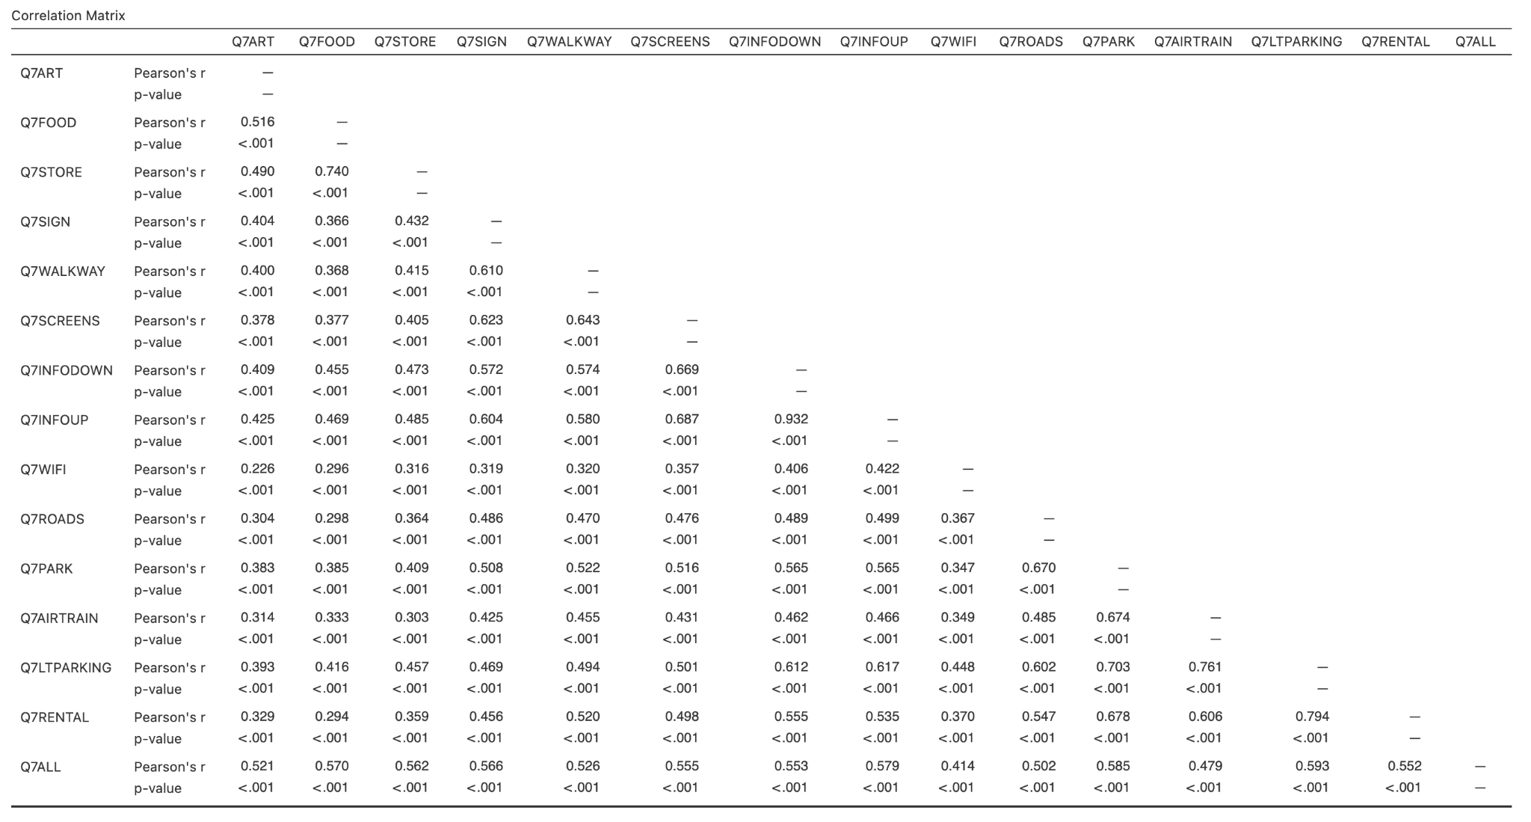

*Appendix 1: Correlation Matrix*

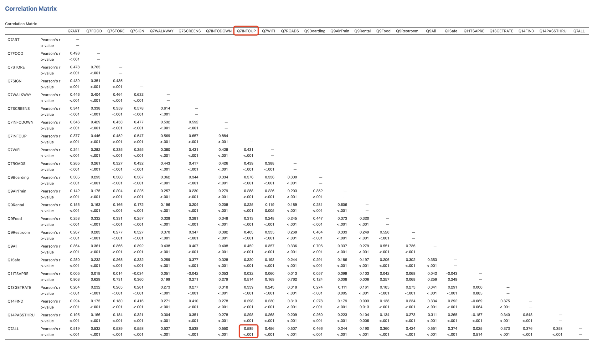

*Appendix 2: Correlation Matrix for Terminal 1*

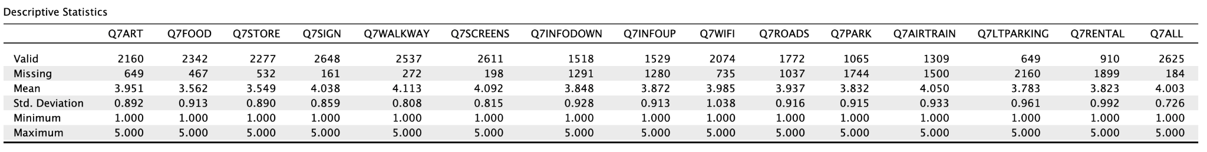

*Appendix 3: Descriptive Statistics for Q7*

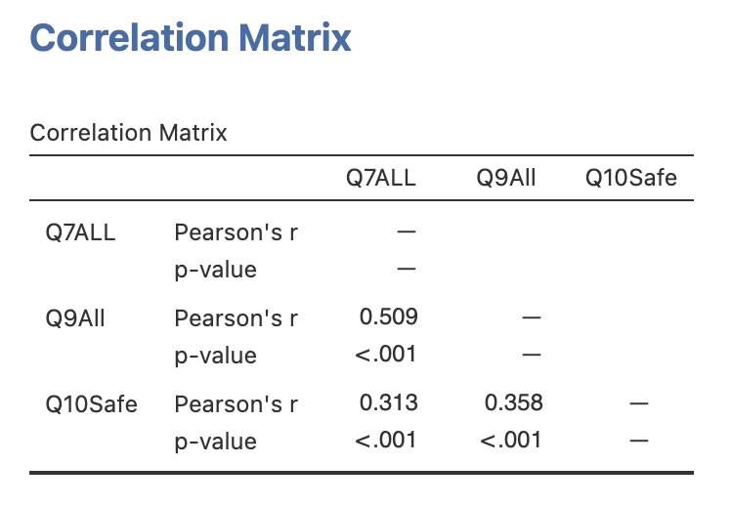

*Appendix 4: Correlation Matrix for Q7ALL, Q9ALL and Q10Safe*